**Exercise 1: Logging Error Messages and Warning Levels**

1. **LoggerExample.java**

package org.example;

import java.util.logging.Level;

import java.util.logging.Logger;

public class LoggerExample {

// ✅ Create a logger

private static final Logger logger = Logger.getLogger(LoggerExample.class.getName());

public void processSomething(int value) {

logger.info("Process started...");

if (value < 0) {

logger.warning("Warning: Negative value received");

}

if (value == 0) {

logger.severe("Error: Value is zero — cannot process!");

}

logger.info("Process completed.");

}

**public static void main(String[] args) {**

**LoggerExample example = new LoggerExample();**

**example.processSomething(10); // Just normal info**

**example.processSomething(-5); // Triggers warning**

**example.processSomething(0); // Triggers severe error**

**}**

**}**

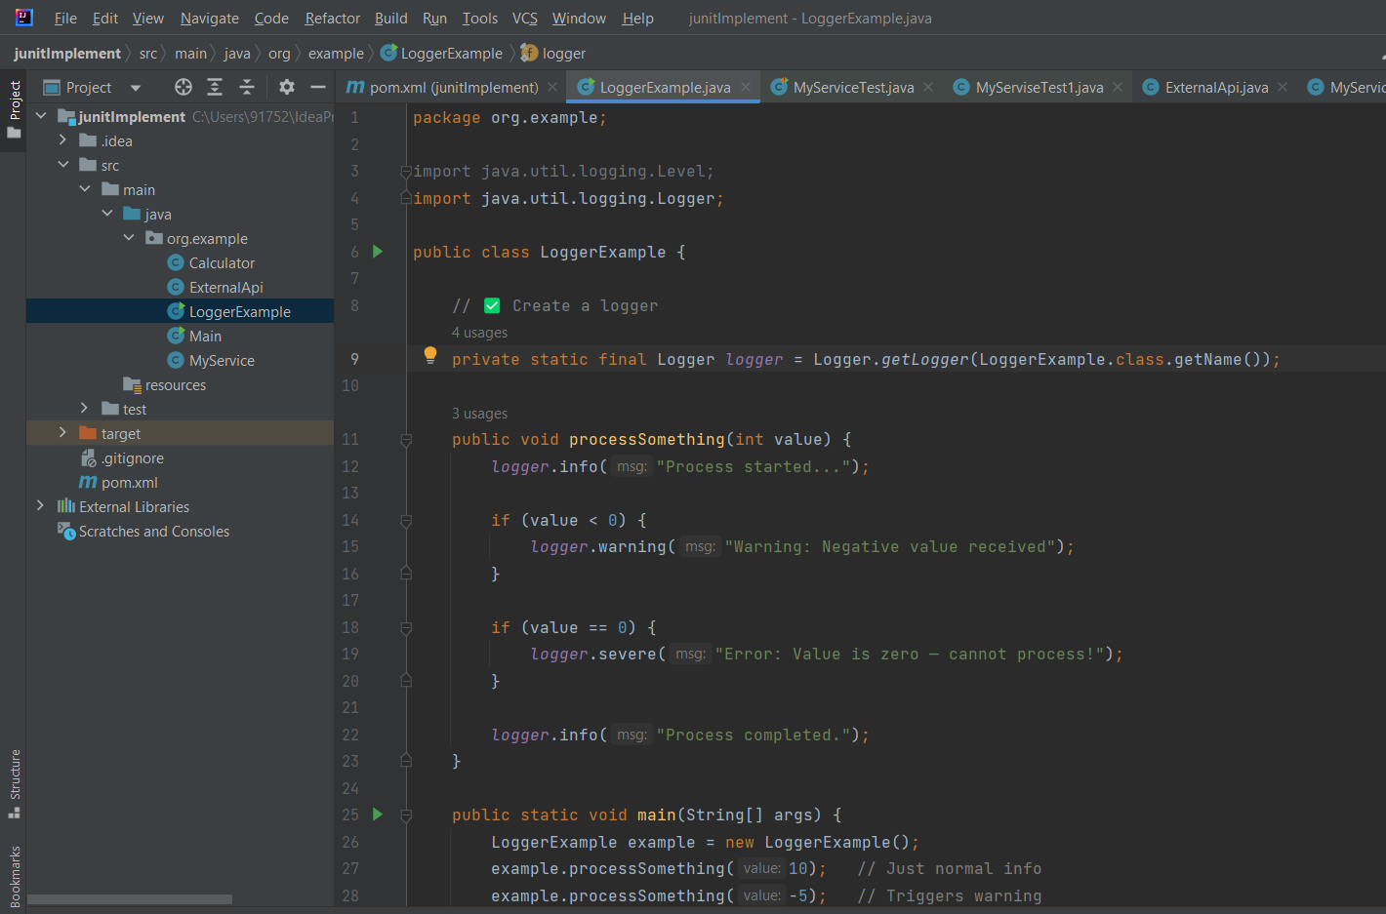

**2-Output**

